**KANADA**

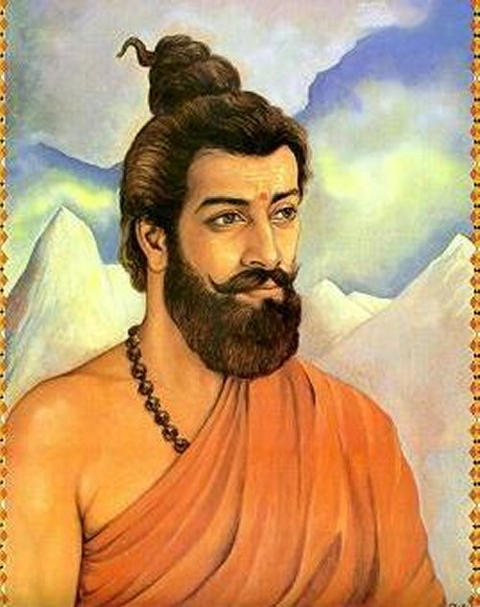

When the entire people credit the Western World for modern physics and its development, it is India’s own scientist “Sage Kanad”, otherwise known as “Acharya Kanad”, who should be highly revered and credited. He discovered the atomic structure, atomic theory, and even sub-atomic particles some 2600 years before. Kanad in Sanskrit denotes the smallest particle.

He is revered as the “Father of Atomic Theory”. He has rendered Kanada Sutras, which are the Aphorisms of Kanada, which is considered as one of the greatest works in the field of physics. He is not only revered in Hinduism but also in Jainism and Buddhism, where his concepts are highly praised.

**Early Life**

He was believed to have born in the year 600 BC or 800 BC in Gujarat, India. His father was a philosopher Ulka. His birth name was Kashyap. As a child, he always accompanied his father and observed many things. But despite of all those things around him, his interest was always on the smallest things. He was able to look beyond the general concepts which were underlying in the universe.

When he was able to conceptualize the idea of the smallest particle, he noted down his ideas and was able to explain it to people. Many people also with great reverence call him Acharya Kanad.

**Legend of Acharya Kanad**

When Acharya Kanad was young, he always admired the grain of rice. It was the tradition of the early Hindu family, to scatter grains of rice along the streets, for the people to follow it as a ritual. The young boy was looking at the ant, which was eating the rice. He was fascinated by the idea that a small piece of rice could become food for a small creature like an ant, but it needs a lot of grains, collected together to make a complete meal for a person, which could satiate his hunger.

The idea of looking deep and beyond was highly fascinating, and he started to look deep into the rice particle, which suggested to him the concept of “Anu”, the smallest particle.

**Ideology**

Physics is central to Kaṇāda's assertion that all that is knowable is based on motion. His ascribing centrality to physics in the understanding of the universe also follows from his invariance principles. For example, he says that the atom must be spherical since it should be the same in all dimensions. He asserts that all substances are composed of four types of atoms, two of which have mass and two are massless.

Kanada presents his work within a larger moral framework by defining Dharma as that which brings about material progress and highest good. He follows this Sutra with another that asserts that the Vedas have gained respect because they teach such Dharma, and something is not Dharma simply because it is in the Vedas.

Kanada and early Vaisheshika scholars focused on the evolution of the universe by law. However, this was not unusual for his times since several major early versions of Hindu philosophies such as Samkhya, Nyaya, Mimamsa along with sub-schools of Yoga and Vedanta, as well as non-Vedic schools such as Jainism and Buddhism, were similarly non-theistic. Kanada was among the sages of India who believed in man's potential to understand existence and reach [moksha](https://en.wikipedia.org/wiki/Moksha) on his own, without God, a notion of ancient Indians summarized by Nietzsche as the belief that "with piety and knowledge of the Veda, nothing is impossible".

The text states:

* There are nine constituents of realities: four classes of [atoms](https://en.wikipedia.org/wiki/Atoms) (earth, water, light and air), space ([akasha](https://en.wikipedia.org/wiki/Akasha)), time ([kāla](https://en.wikipedia.org/wiki/K%C4%81la_(time))), direction (disha), infinity of souls ([Atman](https://en.wikipedia.org/wiki/%C4%80tman_(Hinduism))), mind ([manas](https://en.wikipedia.org/wiki/Manas_(early_Buddhism))).
* Every object of creation is made of atoms (paramāṇu) which in turn connect with each other to form molecules (aṇu). Atoms are eternal, and their combinations constitute the empirical material world.
* Individual souls are eternal and pervade material bodies for a time.
* There are six categories ([padārtha](https://en.wikipedia.org/wiki/Pad%C4%81rtha)) of experience — substance, quality, activity, generality, particularity, and inherence.

Several traits of substances ([dravya](https://en.wikipedia.org/wiki/Dravya)) are given as colour, taste, smell, touch, number, size, the separate, coupling and uncoupling, priority and posterity, comprehension, pleasure and pain, attraction and revulsion, and wishes.[[30]](https://en.wikipedia.org/wiki/Kanada_(philosopher)#cite_note-31)

Thus the idea of the subdivision is carried further to analytical categories as well, which explains its affinity with [Nyaya](https://en.wikipedia.org/wiki/Nyaya).

Apart from this Kaṇāda might have already presented the same laws of motion attributed to Newton, as part of the Vaiśeṣika Sutras.

*वेगः निमित्तविशेषात कर्मणो जायते। वेगः निमित्तापेक्षात कर्मणो जायते नियतदिक क्रियाप्रबन्धहेतु। वेगः संयोगविशेषविरोधी॥*

Meaning, action on objects generates motion. The external action being direction causes the motion to be directional. An equal and opposite action can neutralize the motion.

### **Observations and theories**

In the fifth chapter of Vaisheshika Sutra, Kanada mentions various empirical observations and natural phenomena such as the falling of objects to the ground, rising of fire and heat upwards, the growth of grass upwards, the nature of rainfall and thunderstorms, the flow of liquids, the movement towards a magnet among many others, asks why these things happen, then attempts to integrate his observations with his theories on atoms, molecules, and their interaction. He classifies observed events into two: those caused by volition, and those caused by subject-object conjunctions.[[24]](https://en.wikipedia.org/wiki/Kanada_(philosopher)#cite_note-FOOTNOTEBimal_Krishna_Matilal197757-25)[[31]](https://en.wikipedia.org/wiki/Kanada_(philosopher)#cite_note-32)[[32]](https://en.wikipedia.org/wiki/Kanada_(philosopher)#cite_note-wells-33)

His idea of the observer, that is the subject, being different from objective reality is completely consistent with [Vedanta](https://en.wikipedia.org/wiki/Vedanta), which speaks of the difference between "Apara" and "Para" knowledge, where "Apara" represents normal associational knowledge whereas "Para" represents deeper subjective knowledge.

### **The concept of anu (atom)**

Kanada proposes that *paramanu* ([atom](https://en.wikipedia.org/wiki/Atom)) is an indestructible particle of matter. The atom is indivisible because it is a state at which no measurement can be attributed. He used invariance arguments to determine properties of the atoms. He also stated that *anu* can have two states -- absolute rest and a state of motion.

Adherents of the school of philosophy founded by Kanada considered the [atom](https://en.wikipedia.org/wiki/Atom) to be indestructible, and hence eternal. They believed atoms to be minute objects invisible to the naked eye which come into being and vanish in an instant. Vaiseshikas further held that atoms of the same substance combined with each other to produce dvyanuka ([diatomic molecules](https://en.wikipedia.org/wiki/Diatomic_molecule)) and tryanuka ([triatomic molecules](https://en.wikipedia.org/wiki/Triatomic_molecule)). Kanada also put forward the idea that atoms could be combined in various ways to produce chemical changes in presence of other factors such as heat. He gave blackening of earthen pot and ripening of fruit as examples of this phenomenon.

Kanada postulated four different kinds of atoms: two with mass, and two without. Each substance is supposed to consist of all four kinds of atoms.

Kanada's conception of the [atom](https://en.wikipedia.org/wiki/Atom) was likely independent from the similar concept among the ancient Greeks, because of the differences between the theories. For example, Kanada suggested that atoms as building blocks differ both qualitatively and quantitatively, while Greeks suggested that atoms differed only quantitatively but not qualitatively.

Thus, great philosophers and Saints like Sage Kanad were parallelly able to travel on both philosophy and spirituality. He has made several people think about science and was a great inspiration for several other philosophers and thinkers.